Intel ® Celeron® J1900 Quad Core Processor Mini PC
Nano N3

Features：
◇ All aluminum structure，fanless design；
◇ Onboard Intel Celeron J1900 or N3540 quad core
processor Optional；
◇ Max. Support DDR3L 8GB RAM；
◇ Support 1*MSATA，1*2.5” HDD；
◇ Support 2*1000M LAN；
◇ Support OS：
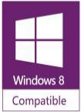
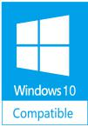


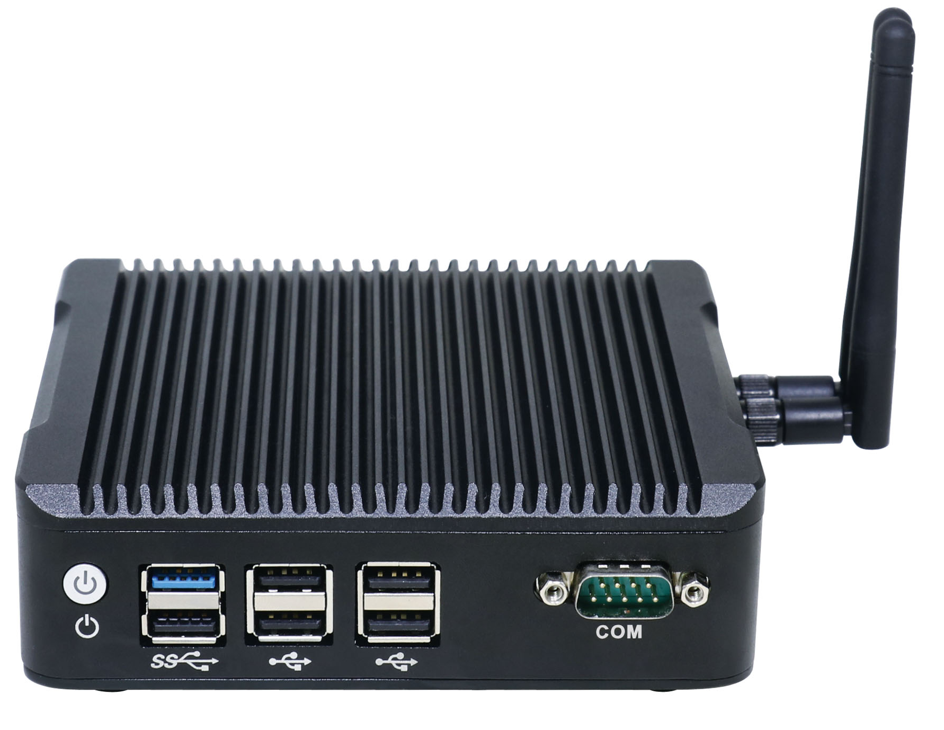

Specification
Model | Nano N3
Color | Black (Color can be customized)
Material | High-quality all aluminum，surface anodic oxidation
Processor | Onboard Intel Celeron J1900（Quad core quad threading，2MB Second Level Cache 1.99GHz, pulse frequency 2.42GHz）
Processor | Onboard Intel Pentium N3540（Quad core quad threading，2MB cache，2..16GHz，pulse frequency 2.66GHz）
Chipset | J1900 or N3540（Single Chip)
RAM | Support 1*DDR3L 1333/1600MHz SODIMMRAM slot，Max. Support 8GB
BIOS | AMI UEFI BIOS
Display Chip | Integrated Intel HD Graphics
Display Port | 1*VGA，1*HDMI（Support synchronous and asynchronous dual display）
Front I/O | 1*Power Switch，1*USB3.0，5*USB2.0，1*RS232 COM
Rear I/O | 1*Audio，2*RJ45 LAN，1*VGA，1*HDMI，1*DC Input
Expansion Slot | Support 1*MINI PCIE Slot（WIFI and Bluetooth Optional）
Expansion Slot | Support 1*MINI PCIE Slot（Support MSATA）
Network | 2*10/100/1000M RTL8111E 1000M LAN
Storage | 1*MSATA，1*2.5” HDD
Input Voltage | Support DC 12V Input
Other Function | Auto power on when there is electricity、Timing boot、Wake on LAN、PXE boot、Watchdog（0～255 level）
Work Temp | 0℃ ～ +50℃（Commercial HDD），-20℃ ～ +50℃（Industrial SSD），Surface air flow
Work Humidity | 5% ～ 95% non-condensing
Certificates | CE、 CCC、 FCC Class A、 ROHS
Dimension | 134 * 126 * 38.5 mm
Net Weight | 0.7kg
Application | Industrial Automation, Medical, Logistics Transportation, Warehouse, Electronic Education etc.

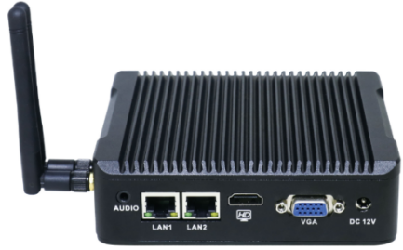
Nano N3 Drawing
Accessories List
Name | Quantity | Specification
Power Adapter | 1 | 12V4A
Power Cord | 1 | Any Plug Optional  (China, US, EU, UK etc.)
VESA Bracket | 1 | Standard

Order Information
Configuration 1 | Nano N3 | Intel Celeron J1900 | Standard Port，6*USB，1*COM
Configuration 1 | Nano N3 | Intel Pentium N3540 | Standard Port，6*USB，1*COM

